 |  |  | 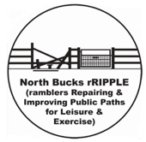

North Bucks rRIPPLE
ramblers Repairing & Improving Public Paths for Leisure & Exercise

‘Donate a Gate’

Please enter your details in the boxes provided:
Title (Mr, Mrs, etc): |  | Name:
Address: (please include postcode)
Telephone: | Home: | Mobile:
Email:
Gift Aid:  (Please tick*) | I confirm that I am a UK taxpayer and wish Ramblers to claim Gift Aid on my donation (* Delete this statement if it is not applicable, or if the gate is to be installed on your land, as your donation will then be ineligible under the Gift Aid scheme.)
Signed: Date:

Please read the T&Cs on page 2. Your signature can be typed if you are submitting this form electronically.
Optional free inscribed plaque to be attached to the gate. It is not mandatory to have a plaque. Please enter below in the space provided what you would like in the way of an inscription on the plaque on your donated gate. The shape and size of the plaque will be approximately as shown at 185 x 85mm. If you are donating more than one gate, you can provide different inscriptions for each gate, if required.
 |  | Your dedication: (amend as required)  Donated by  Mr and Mrs Walker  Installed by North Bucks rRIPPLE volunteers  www.bucks-wmiddx-ramblers.org.uk
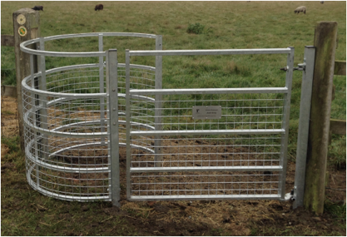 |  | 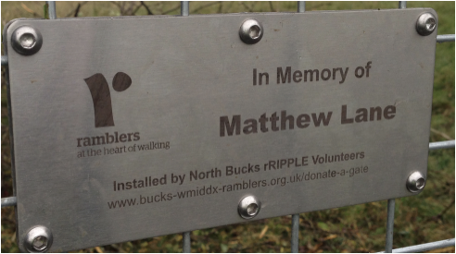

The Donate a Gate scheme organiser is:
Bill Piers, NB rRIPPLE Co-ordinator, 48 Stokes End, Haddenham, Bucks HP17 8DX.
Tel 01844 290923; Mob 07799 110128 or email williamjsbpiers@gmail.com

 | Gift Aid is a government programme that allows charities to claim back tax  on donations. The scheme enables the Ramblers to receive an additional 25p from HM Revenue & Customs for every £1 donated. Please delete the relevant box above if you DO NOT pay income tax or capital gains tax.  If you pay income tax at the higher rate you can claim further relief on your self-assessment form.

By signing this form I agree to the following terms and conditions:
- My donation does not bestow upon me any right of ownership of the gate unless I am the landowner.
- Maintenance of the gate is the responsibility of the landowner.
- As the gate donor, I am responsible for the maintenance of the plaque. (NB rRIPPLE will replace plaques if required. The cost of replacement plaques, around £30, will be borne by the donor.)
- The type of gate to be installed will be the most suitable for the location as determined by the Buckinghamshire Council (BC) Rights of Way Department. BC prefers galvanised steel gates to timber gates and simple pedestrian gates over kissing gates.
- Gate locations will be determined/agreed by the BC Rights of Way Department and the landowner.
- NB rRIPPLE is unable to agree specific locations, but a list of locations for which permission has been obtained to install a gate can be supplied on request. However, any request for a specific location within North Bucks will be passed to the BC Rights of Way Department.
- Gate installation will be completed as soon as possible as part of the normal NB rRIPPLE work programme.
- The scheme organiser will contact the donor to confirm the installation has been completed and the location of the gate.
- The Ramblers will be the sole arbitrator if an inscription is considered unsuitable by the scheme organiser.

I wish to donate……..[number of] pedestrian gate/s at £350 per gate or £500 per kissing gate (delete as appropriate). My preferred location is (6 fig map ref) SP…………. / parish / footpath no.

Payment by electronic transfer is preferred:
Account name: The Ramblers Association (BU)
Account No: 20116275
Account sort code: 60-83-01
I have made an electronic transfer payment of £350 / £500 / other (delete or enter amount………)
Please submit this completed form to Bill Piers at williamjsbpiers@gmail.com.

Alternatively, please send a cheque made payable to: The Ramblers Association (BU) together with this completed form to Bill Piers at the address at the top of this page.

N.B. For groups donating a gate, such as walking groups, whereby a number of different people are all contributing to raise the necessary monies, please collect centrally and submit one payment to The Ramblers. It is difficult for the treasurer to keep track of multiple electronic bank transfers or cheques. Your assistance is much appreciated.
Thank you for supporting the work of the Ramblers.
Form revision 180623

